Biostatistics Data Definitions
Descriptive Statistics
Frequency: The number of times a given value of an observation occurs. It is also called counts. ¹
- Frequency data is the most basic descriptive statistic. There are several cases where frequencies are the only level of information available or because of the nature of the data it can only be shown as a frequency. (Example: environmental quality data like levels of contaminants, which are not measurements of population)
- Example:
The number of community-based dental health clinics 2011
 | Count
Adams County | 13
Region 14 | *
Colorado | 80
* Indicates no data was collected for this indicator

Proportion: The number of observations with the characteristic of interest divided by the total sum of observations. It is used to summarize counts.¹
- Example:
The proportion of community-based dental health clinics in Adams County = 0.1625 (Equation=13/80)
Percentage: A proportion multiplied by 100.¹
- Proportions and percentages frequently appear in the Health Indicators as weighted estimates from survey data. (Weighted estimates take survey results and adjust for local demographics so the estimates reflect the entire population.) This warrants some caution during interpretation as it is not an exact proportion of the entire population but rather an estimate of the proportion.
- Example:
The percentage of community-based dental health clinics in Adams County = 16.3% (Equation=0.1625*100)

Rate: A proportion associated with a multiplier, called the base (eg 1000, 10,000, 100,000) and computed over a specific period.¹
- Population-based rates, like those in the Health Indicators, use population estimates as the base (or denominator). This allows for comparison between different geographies because the rate already accounted for the differences in population size.
- Example:

The rate of community-based dental health clinics in Adams County = 2.9 per 100,000 residents (Equation= [13/442,971]*100,000 where 442,971 is the total population for Adams)

Crude rate: A rate for the entire population that is not specific or adjusted for any given subset of the population.¹
- Crude rates are useful for simple data that are less influenced by age, geography, gender, etc.
- Example:
Rate of healthy food outlets per 10,000 residents 2009
 | Rate
Adams County | 0.8
Region 14 | 0.8
Colorado | 1.1

Age (Sex, Race, etc)-Specific Rate: The number of events in a specified group divided by the total population in the specified group.
- Specific rates are an effective way of looking at a particular population without including the information of the entire population.
- Example: Teen fertility rates use age and gender-specific rates for women aged 15-17 years old instead of the entire population
Rate of live births born to women age 15-17 per 1,000 women age 15-17 2007-2009
 | Rate | Lower Confidence Limit | Upper Confidence Limit
Adams County | 33.4 | 31.3 | 35.5
Region 14 | 33.4 | 31.3 | 35.5
Colorado | 21.2 | 20.7 | 21.7

Age-Adjusted Rate: A rate that has been standardized to the age distribution of a particular population so that it is, in effect, independent of the age distribution of the population it represents. Age-adjusted rates are used to compare rates over time or among different geographical areas.
- Age-adjusted rates are useful for data that are impacted by life course. (Example: Mortality rates vary with age)
- Example:
Age-adjusted rate of heart disease hospitalizations (per 100,000 population) 2007-2009
 | Rate | Lower Confidence Limit | Upper Confidence Limit
Adams County | 3220.8 | 3185.4 | 3256.1
Region 14 | 3220.8 | 3185.4 | 3256.1
Colorado | 2670.6 | 2662.4 | 2678.9

Confidence Interval (Limits): Confidence intervals are statistics used to describe the possible margin of error in a reported rate. Calculating a confidence interval provides a better indication of what the "true" rate might be. A 95 percent confidence interval indicates that the "true" rate will be a value between the lower and upper limits of the confidence interval 95 percent of the time.
- A narrow confidence interval indicates a more stable number/rate.
- Confidence intervals also allow for comparison of like variables. Intervals that overlap do not have a statistically significant relationship. (And vice versa, if there is no overlapping then the values are statistically significant)
- Examples:
Age-adjusted rate for congestive heart failure hospitalizations (per 100,000 population) 2007-2009
Ranges do not overlap = Significant
 | Rate | Lower Confidence Limit | Upper Confidence Limit
Alamosa County | 1007.2 | 914 | 1100.5
Region 8 | 819.9 | 776.9 | 862.9
Colorado | 815.7 | 810.8 | 820.5

Age-adjusted rate for congestive heart failure hospitalizations (per 100,000 population) 2007-2009
 | Rate | Lower Confidence Limit | Upper Confidence Limit | Ranges overlap = NOT Significant
Alamosa County | 1007.2 | 914 | 1100.5
Region 8 | 819.9 | 776.9 | 862.9
Colorado | 815.7 | 810.8 | 820.5

Measures of Central Tendency
Range: The difference between the largest and the smallest observation.¹
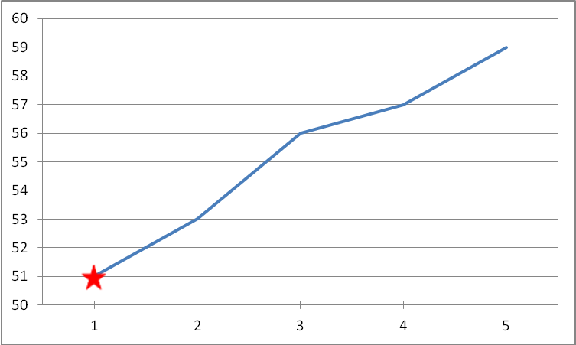
Range → 59-51 = 8

Median: A measure of the value distribution into 2 equal parts with one-half of the values below and one-half above the median value.
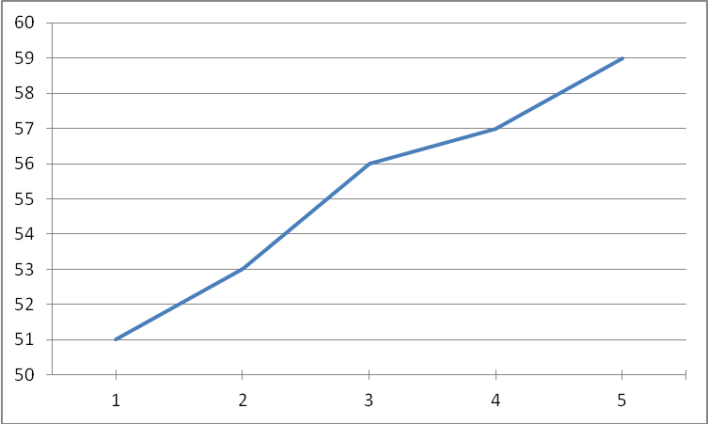
Median →
51 53 56 57 59
Mean: The sum of scores divided by the total number of cases involved.
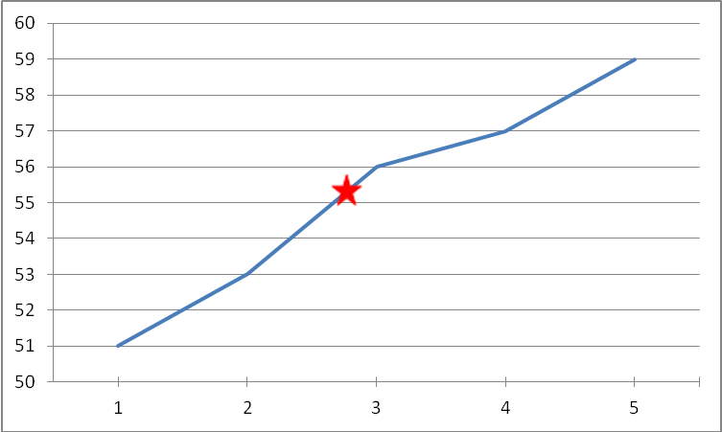
Mean → (51+53+56+57+59)/5 = 55.2

Measurements of Disease
Incidence: The number of new cases of disease onset in a population over a period of time.
Prevalence: The number of existing cases of a disease at a given point in time in a community.
Morbidity: The state of being diseased.
Mortality: The state of being deceased.
Examples:
Incidence= 5 new cases/year from 2005-2010
Prevalence= 675 cases (2005-2010)
Morbidity would measure Disease X among living persons.
Mortality would measure Disease X among deceased persons.
Year | Diagnosed Cases of Disease X
2005 | 100
2006 | 105
2007 | 110
2008 | 115
2009 | 120
2010 | 125

References
- Dawson, Beth, and Robert G. Trapp. Basic & Clinical Biostatistics. 4th ed. New York: Lange Medical Books/McGraw-Hill, 2004. Print.

